SAIL SALEM MEDICAL INFORMATION FORM

Child’s Name: ___________________________________________  
Gender Male □ Female □   
  
  
Medical Insurance:________________________________________  
Policy Number: __________________________________________  
Subscriber’s ID Number: _______________________   
Subscriber’s Name: _______________________________________  
Family Doctor: ___________________________________________  
Doctor’s Phone Number: (___) _____-________   
  
  
Date of latest tetanus shot: ____/ ____/ ____   
Allergies: _______________________________________________  
Current medications: ______________________________________  
Physical Challenges: ______________________________________  
Learning Disabilities:______________________________________  
Worries/Fears:__________________________________________________________________________________________________

MEDICAL PERMISSION: The undersigned hereby authorizes an instructor from the Program or an adult who bears this document to authorize emergency treatment for the Junior Sailor in the event that a parent or legal guardian cannot be reached at the above telephone numbers at the time of the emergency.

Name of Parent or Legal Guardian (Please Print) Date

____________________________________ _______________

Signature of Parent or Legal Guardian

__________________________________________________

**PARENT/STUDENT AGREEMENT**

By accepting this Parent/Student Agreement, we, as the named child herein ("Junior Sailor") and as the parent (guardian) of the Junior Sailor, hereby acknowledge that the execution of this Agreement is a condition of the participation of the Junior Sailor in Sail Salem, Inc.’s Sailing Program (―Program‖).

WAIVER AND MEDICAL PERMISSION

By accepting this Agreement, I, as the parent (guardian), accept that the sport of sailing and the conduct of the Program entail and are subject to certain inherent risks. On behalf of the Junior Sailor I do hereby: 1. Grant my consent to the Junior Sailor’s participation in the Program and agree that this Agreement will extend to the Sail Salem, Inc. (―SSI‖), its Officers, Directors, employees, agents and volunteers.

2. Consent to the participation of the Junior Sailor in sailing events which are a normal part of the Program (regattas and/or events) and agree that this Agreement will extend to the benefit of any sailing clubs or association which is the host to or is the venue of such events. 3. Waive any claims against and release any obligation of SSI, its respective members, officers, directors, employees, volunteers and agents or any other person acting in any capacity for the conduct of the Program (each an ―Indemnified Person‖) in relation to any loss, injury, or damage (on land or at sea or in transportation to the Program or any event) to the Junior Sailor or to the boat or other property of the undersigned or the Junior Sailor to the fullest extent permitted by law.

4. Reimburse SSI and each Indemnified Person for any loss or damage to property, and to indemnify and hold SSI, and each Indemnified Person harmless from any claim, loss or injury caused by the negligence, or misconduct of, or failure to exercise reasonable care by the Junior Sailor. SUBSTANCE ABUSE The Sail Salem, Inc. was organized in 2007 to provide the young people of Salem and its surrounding communities a comprehensive opportunity to learn the sport of sailing, experience the joys of boating, acquire an enduring respect for the water and share in the fellowship of each other's company. However, it is incumbent on sailors to be fully aware of what is around them and requires all of a person’s faculties without any impairment. SSI offers or will offer a variety of opportunities for the novice to the experienced sailor. Participants are expected to comport themselves in ways which reflect pride in themselves, SSI, and the community. They are expected to set good examples at all times when sailing off Winter Island or while away at a regatta. Participants are subject to SSI policies regarding use of alcohol and drugs. Since the goal of SSI is to develop a respect for boats, water, others and ourselves, we expect participants to obey all local and state laws. Therefore, the use of alcohol or drugs is illegal. At any time while you are enrolled in SSI, you are expected to refrain from situations when your conduct may reflect detrimentally on the reputation of yourself and the SSI program in the community. Participants violating SSI policy regarding the illegal use of alcohol and drugs will incur the following penalties, in addition to legal penalties that may be incurred through proper authorities:

1. For a first violation, the participants will be suspended from all SSI activities and classes for a period of two weeks. No fees will be refunded for loss of time. 2. Any subsequent violation, the sailor will be removed from the program. We, as the parent (guardian) and Junior Sailor have read and understand the policy regarding the illegal use of alcohol and drugs. I am aware of the consequences for violating the rules and promise to adhere to these rules.

Name of Parent or Legal Guardian (Please Print) Date

____________________________________ _______________

Signature

____________________________________

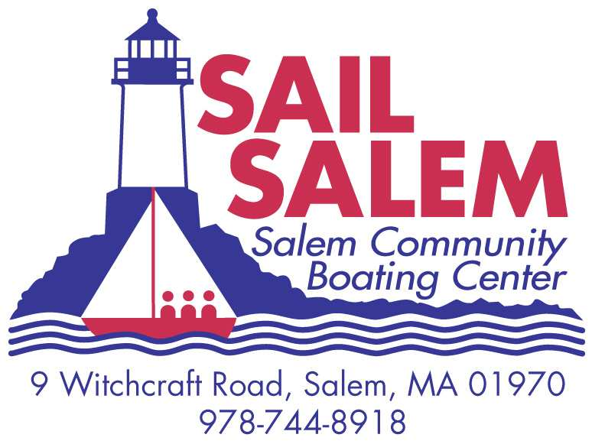

This form certifies that my child __________________________________ (child name) is comfortable swimming 75 yards, and has done so in the presence of a certified instructor or lifeguard on this date: ____________________ (date) at the following facility_____________________________ (facility name).

___________________________________________(Parent Signature)

___________________________________________(Print Parent’s Name)

___________________________________ (Certified Instructor or Life Guard Signature)

___________________________________ (Print Instructor’s Name)

*Please bring this completed form with you on the first day. Please understand for your child’s own safety, the *Sail Salem, Inc. will not allow your child to participate in the program unless a fully completed swim certificate has been received*.  Both a certified instructor **or** lifeguard ***and*** a parent must sign the form. Thank You.

**If you are looking for a place to have the swim test, the Salem YMCA will test your child at no charge at their facility with their lifeguards. Just bring this form to a lifeguard and ask to be tested. The hours for testing are 5:00 a.m. – 9:45 p.m. Monday through Friday; Saturdays 6:00 a.m. to 6:45 p.m. and Sunday 7:00 a.m. to 5:45 a.m.